**請使用Pthread完成本次作業**

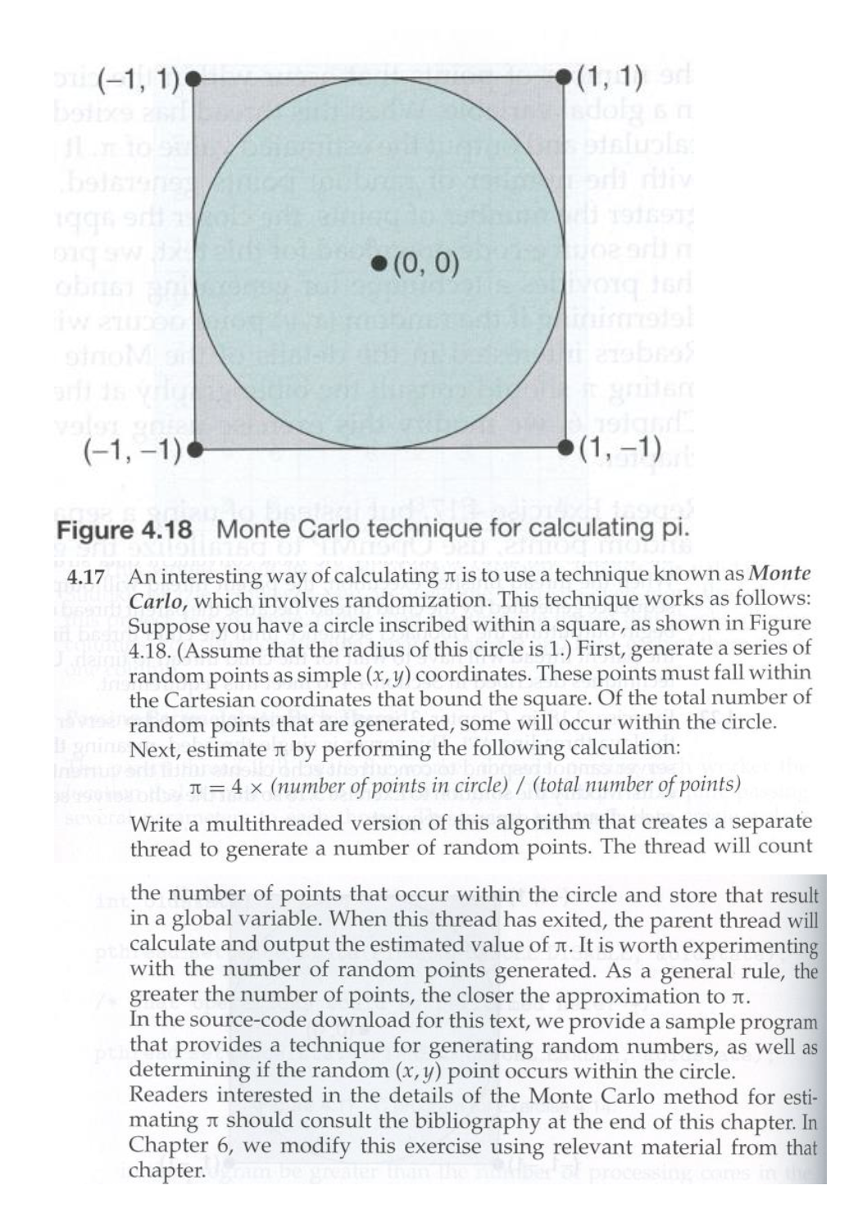

上述 “determining if the random (x,y) point occurs within the circle” 請參考下面連結: <https://www.geeksforgeeks.org/estimating-value-pi-using-monte-carlo/>

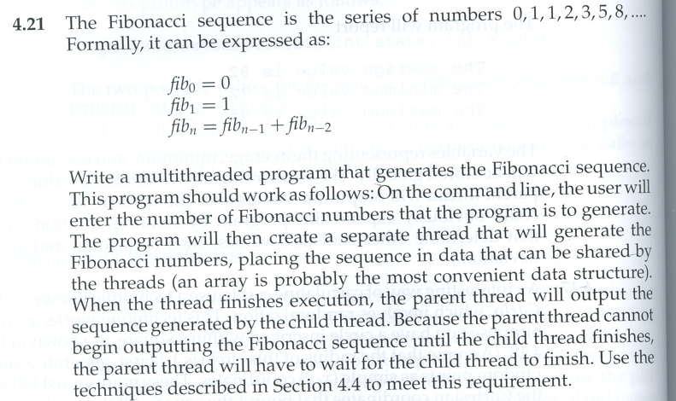

**請完成Project 2 – multithreaded sorting application**

